CHORDS USED IN THIS SONG  C  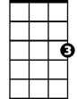  G7  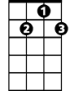  C7  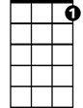  F  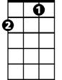  F7  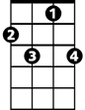  A7  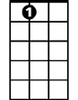  D7  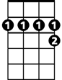  Dm  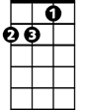 | "Mele Kalikimaka" by R. Alex Anderson  Intro  Dm G7 C  [C]Mele Kalikimaka is the thing to say  On a bright Hawaiian Christmas [G7]Day  That's the island greeting that we send to you  From the land where palm trees [C]sway [C7]  [F]Here we know that Christmas will be [F7]green and bright  The [A7]sun will shine by day and all the [D7]stars by [G7]night  [C]Mele Kalikimaka is Ha[C7]waii's [A7]way  To [Dm]say Merry [G7]Christmas to [C]you  Slide Guitar Solo  Kazoo Solo  Repeat song  To finish repeat last line.

